Lab 6
Q1:
#include<iostream>
using namespace std;

class Node{
private:
int data;
Node* next;
public:
Node(){
data = 0;
next = NULL;
}

int getData(){
return data;
}
void setData(int data){
this->data = data;
}
Node* getNext(){
return next;
}
void setNext(Node* next){
this->next = next;
}

};
class LinkedQueue{
private:
Node * front;
Node * rear;
public:
LinkedQueue(){
front = rear = NULL;
}
bool isEmpty(){
if(front == NULL){
return true;
}else{
return false;
}
}

void Enqueue(int data){
Node *newNode = new Node();
newNode->setData(data);
newNode->setNext(NULL);
if (front == NULL)
{
front = rear = newNode;
}else{
rear->setNext(newNode);
rear = newNode;
}

}

void Dequeue(){
Node *temp= front;
front = front->getNext();
delete temp;
}

int getFront(){
return front->getData();
}

void printQueue(){
Node *temp = front;
if (front == NULL)
{
cout<<"Queue is Empty";
}else{
while (temp != NULL)
{
cout<<temp->getData()<<" ";
temp = temp->getNext();
}
cout<<endl;
}

}
};

int main(){
LinkedQueue lst;
lst.Enqueue(100);
lst.printQueue();
lst.Enqueue(200);
lst.printQueue();
lst.Enqueue(300);
lst.printQueue();
lst.Enqueue(400);
lst.printQueue();

cout<<"The front element is "<<lst.getFront()<<endl;
}
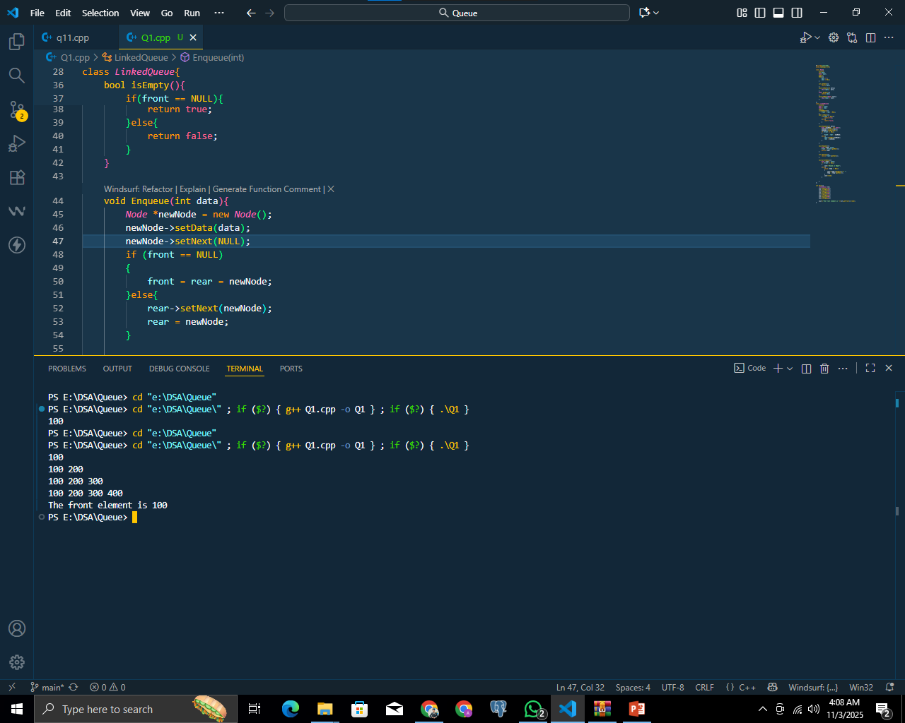
Q2:
#include <iostream>
using namespace std;
# define Queue_Size 5
class QueueArray{
private:
int queue[Queue_Size];
int front;
int rear;
public:
QueueArray(){
front = -1;
rear = -1;
}

int size(){
return rear + 1;

}
bool isEmpty(){
if(front == -1 && rear == -1){
return true;
}else{
return false;
}
}

bool isFull(){
if(rear == Queue_Size - 1){
return true;
}else{
return false;
}
}

void Enqueue(int data){
if (isFull()==true)
{
cout<<"Queue is Full"<<endl;
}else{
queue[++rear] = data;
if (front == -1)
{
front = 0;
}

}

}

void Dequeue(){
if (isEmpty()==true)
{
cout<<"Queue is Empty"<<endl;
}else{
front++;
}
}

void PrintQueue(){
if (isEmpty() == true)
{
cout<<"The queue is Empty"<<endl;
}else{
for (int i = front; i <= rear; i++)
{
cout<<queue[i]<<" ";
}
cout<<endl;
}

}
};
int main(){
QueueArray q1;
q1.Enqueue(100);

q1.Enqueue(200);

q1.Enqueue(300);

q1.Enqueue(400);

q1.Enqueue(500);
q1.PrintQueue();

return 0;
}
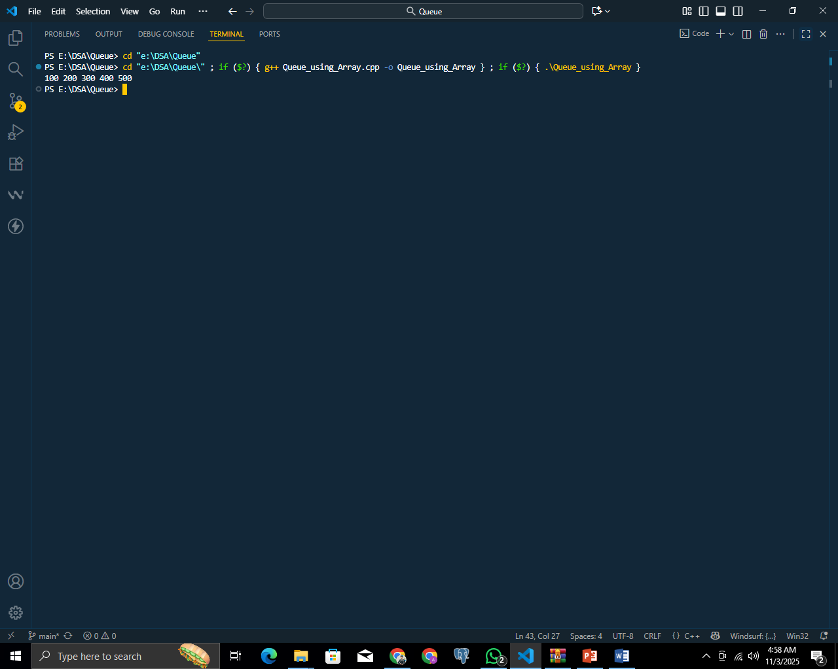
Q3:
#include <iostream>
using namespace std;

#define Queue_Size 5

class QueueArray {
private:
int queue[Queue_Size];
int front;
int rear;

public:
QueueArray() {
front = -1;
rear = -1;
}

bool isEmpty() {
return (front == -1 && rear == -1);
}

bool isFull() {
return (rear == Queue_Size - 1);
}

void Enqueue(int data) {
if (isFull()) {
cout << "Queue is Full!" << endl;
} else {
if (front == -1) front = 0;
queue[++rear] = data;
cout << "Inserted: " << data << endl;
}
}

void Dequeue() {
if (isEmpty()) {
cout << "Queue is Empty!" << endl;
} else {
cout << "Deleted: " << queue[front] << endl;
if (front == rear) {
front = rear = -1;
} else {
front++;
}
}
}

void PrintQueue() {
if (isEmpty()) {
cout << "The queue is Empty!" << endl;
} else {
cout << "Queue elements: ";
for (int i = front; i <= rear; i++) {
cout << queue[i] << " ";
}
cout << endl;
}
}
};

int main() {
QueueArray q;
int choice, value;

while (true) {
cout << "\n==== Queue Menu ====\n";
cout << "1. Insert Element into Queue\n";
cout << "2. Delete Element from Queue\n";
cout << "3. Display the Queue\n";
cout << "4. Exit\n";
cout << "Enter your choice: ";
cin >> choice;

switch (choice) {
case 1:
cout << "Enter value to insert: ";
cin >> value;
q.Enqueue(value);
break;
case 2:
q.Dequeue();
break;
case 3:
q.PrintQueue();
break;
case 4:
cout << "Exiting program..." << endl;
return 0;
default:
cout << "Invalid choice! Please enter 1-4." << endl;
}
}
}
